Littleneckhalfshell
- Plunderer
- Member

- 390 posts
- Gender:Male
- Location:Hudson Valley, NY
- Interests:Blacksmithing, hunting, fishing, stuff.......
(IP: 24.105.217.139) ·
Posted February 25, 2010 (edited) · Report post
I came across a good two foot section of three inch diameter lead (Pb) pipe in my 'useful junk' pile the other day and it got me to thinking, in what form was lead usually found aboard ship or being shipped during the GAOP? We need lead to shoot the pistols and muskets, and shot for the fowling pieces. Was it to be found already cast into lead balls and packed in bags or kegs? I assume rolls of lead sheet may also be found for other particular uses, but were you likely to see large or small 'bars' of lead?
Though I would assume that lead shot were not often cast aboard ship (due to the fire danger) what about ashore? The Buccaneers needed shot too, did they acquire it already cast into shot of the proper size or did they carry molds to cast shot for their personal weapons? a supply of powder, flints, and shot would be necessary, so any idea on the form of the lead ?
I would like to cast or shape my lead pipe into something 'period'
Edited February 25, 2010 by Littleneckhalfshell

- Quote
- Edit

Hawkyns
- Curmudgeon With A Cannon
- Moderator

- 1,330 posts
- Gender:Male
- Location:New Haven Colony
- Interests:cannon, swords, cannon, wenches, cannon, muskets, cannon, pistols, cannon, re-enacting, cannon, rum, cannon, living history......... Did I mention cannon?
(IP: 75.28.150.240) · ·
Posted February 25, 2010 · Report post
Musket balls were shipped in kegs for military purposes. Civilian is another story. Since most civilian weapons were one of a kind, they were of varying, non standard calibres. Most weapons would come with a ball mold for casting your own shot. I have a copy of a mold that has 3 different sizes of ball, .69, .50, and .35. For a musket, this means I could cast full bore ball, buckshot, or swanshot. Smaller bars of lead were cast, small enough to go into shooting bags, as well as the ingots that could be cut up as needed.
Just be sure, if you are going to melt that pipe down, that it is clean and dry on the inside. Impurities, especially liquids, can make a pot of melted lead sputter or even explode, and it will spray molten lead over quite a distance.
Hawkyns

- Quote
- Edit
- Options

Daniel
- Pyrate Captain
- Member

- 652 posts
- Gender:Male
- Location:McLean, VA
- Interests:History, pirates, fiction, writing, writing historical fiction about pirates, jokes, games, law.
(IP: 204.13.181.13) · ·
Posted February 25, 2010 · Report post
Just found something about this in Jameson's Privateering and Piracy in Colonial America, p. 177. Samuel Perkins, aboard the pirate ship Resolution, reported that they took "several Piggs of Lead" out of a Danish sloop near the southern tip of India.

- Quote
- Edit
- Options

Capt. Bo of the WTF co.
- Scourge o' the 7 Seas
- Member

- 2,339 posts
- Gender:Male
- Location:Spanish Louisiana - on the river Osage
- Interests:Many and varied.
(IP: 64.85.220.234) · ·
Posted February 25, 2010 · Report post
I have no pictures to show, but I hand-carved a block of walnut with some grooves that produce half-pound bars of lead similar to some excavated at sites in the North-east colonies in America. Nothing fancy or pretty, but they came out very much like the originals. They are about eight inches long and on inch wide by appx. 5/8" thick. Think of a long, narrow, leaden "lady-finger" cookie. These are easy to cut chunks off of with a belt axe to cast shot/ball. Mt camera is dead so i cannot show them to you. The lead bars are in the fur trade museum i think, and there are some others that are in tLouis and are from the galena ore district of Mo. Potosi, Mo. is home to the mining museum and archives, they may have the info I am thinking of.
One of the demos I do is cast ball and I give a little history on lead-mining techniques and growth in Missouri.
Bo

- Quote
- Edit
- Options

Littleneckhalfshell
- Plunderer
- Member

- 390 posts
- Gender:Male
- Location:Hudson Valley, NY
- Interests:Blacksmithing, hunting, fishing, stuff.......
(IP: 24.105.217.139) · ·
Posted February 25, 2010 (edited) · Report post
Hawkyns wrote ""Just be sure, if you are going to melt that pipe down, that it is clean and dry on the inside. Impurities, especially liquids, can make a pot of melted lead sputter or even explode, and it will spray molten lead over quite a distance.""
No worries there, it has set in a box in my very dry basement for maybe 15 years :-) from the last time I cut some off to cast some ball for my flintlock.
Thanks for the replys, now if I can just get a picture. I have had lead that was in the long lady finger shape, (I think that is how the lead came for plumbers year's ago), I also have had bars and ingots and even an end of a 'pig' sort of chunk maybe three inches wide on the flat top and rounded on the bottom and one end I had.
The main idea would be to mold the lead into something that does not look out of place in the GAOP, to demonstrate the process from bulk lead to lead ball, and for that I think I need a picture. So far Google has let me down in finding one. :-(
Edited February 25, 2010 by Littleneckhalfshell

- Quote
- Edit
- Options

Hawkyns
- Curmudgeon With A Cannon
- Moderator

- 1,330 posts
- Gender:Male
- Location:New Haven Colony
- Interests:cannon, swords, cannon, wenches, cannon, muskets, cannon, pistols, cannon, re-enacting, cannon, rum, cannon, living history......... Did I mention cannon?
(IP: 75.28.150.240) · ·
Posted February 25, 2010 (edited) · Report post
Pictures of period lead, not so much.
How about, though, pictures of silver ingots from the Atocha? The casting procedure and molds would be similar.
http://www.insideflorida.com/images/cities/mel_fisher_silverbars_thumb.jpg
Hawkyns
Edited February 25, 2010 by Hawkyns

- Quote
- Edit
- Options

Jas. Hook
- Scourge o' the 7 Seas
- Member

- 1,650 posts
- Gender:Male
- Location:Long Island NY
- Interests:Fishing & Piracy
(IP: 68.161.60.188) · ·
Posted February 27, 2010 (edited) · Report post
On 2/25/2010 at 6:18 PM, Hawkyns said:
Pictures of period lead, not so much.
How about, though, pictures of silver ingots from the Atocha? The casting procedure and molds would be similar.
Hawkyns
With all that silver we could cast enough silver bullets to fend off a horde of the undead.
I think that for purely economic reasons the base metal in some form of ingot or bars would be the cheapest form to ship and resell. Once the product was cast and keged ie: musket or pistol balls, that additional cost would have to be passed along to the end user. The military might purchase in bulk but a sutler would more likely purchase and resell bars. As fas as piracy... grab what you find.
Jas. Hook
Edited February 27, 2010 by Jas. Hook

- Quote
- Edit
- Options

Patrick Hand
- The sailor's sailor
- Moderator

- 6,100 posts
- Gender:Male
- Location:TH' Mountains of Central California
- Interests:I like wierdness... Klingon, Pyrate..... and even..... gasp.... Renn Faires...... (Baseball and tractor pulls I'd have to think about.... could be wierd or Not,,,,)
(IP: 98.224.0.63) · ·
Posted February 27, 2010 · Report post
The only references that I have are from the Fur trade era. This is from The Mountain Man's Sketch book volume two by James Hanson and Kathryn Wilson.
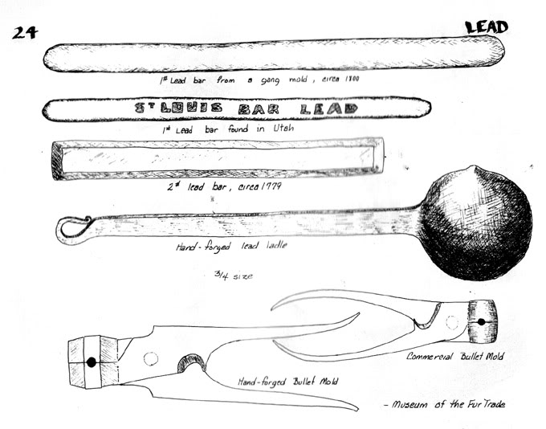

- Quote
- Edit
- Options

Capt. Bo of the WTF co.
- Scourge o' the 7 Seas
- Member

- 2,339 posts
- Gender:Male
- Location:Spanish Louisiana - on the river Osage
- Interests:Many and varied.
(IP: 64.85.222.3) · ·
Posted February 27, 2010 · Report post
That top one is what my "piggin" bars look like, thanx Patrick. Mine are only @1/2 pounf though, easier to carry in the shooting bag for long hikes where I may need extra shot, or can be traded to the natives. :angry: I made one like the bottom sketch too. but with indents to make it easier to break-off pieces like a candy-bar, but it didn't last long because the lead burnt off the indents after seven or eight castings.
Bo

- Quote
- Edit
- Options

Dutchman
- Has anyone seen my cousin?
- Admin

- 1,773 posts
- Gender:Male
- Location:tidewater virginia
(IP: 198.246.136.35) · ·
Posted February 27, 2010 · Report post
certainly not period, but i have a stack of piggs behind the barn. they are about 8x8x24 inches long. This seems to be a pretty common size, but no idea how far back they go. Piggs tend to chance sizes depending on the ship. smaller vessels need to take advantage of every inch so some pretty odd piggs get created, where larger vessels can get away with stacking and securing them, then filling the voids with smaller pieces.

- Quote
- Edit
- Options

Littleneckhalfshell
- Plunderer
- Member

- 390 posts
- Gender:Male
- Location:Hudson Valley, NY
- Interests:Blacksmithing, hunting, fishing, stuff.......
(IP: 24.105.217.139) · ·
Posted February 28, 2010 · Report post
Thanks, especially Patrick for the picture references. Too bad there are not any references to lead bars found in Port Royal excavations or any of the other ships that sank during the period. I remember looking at a lot of pictures of artifacts over the years, but can't remember any of lead. The big silver ingots I think are meant to be on an industrial scale, (and a big bar like that is not easily pilfered ) But I would think that lead for use (melting into balls) or trade would be in a smaller form, much like the fur trade ones Patrick posted. Just wish there were some for GAOP, in the mean time, I will likely make a mold for one of the bars pictured.

- Quote
- Edit
- Options

Dorian Lasseter
- Where's My Water
- Member

- 3,266 posts
- Gender:Male
- Location:The Sea!
- Interests:18th Century reenactment; Maritime, F&I...
Did ECW as well...
All BP firelocks and cannons!
Also enjoy Swordfighting and a good Donnybrook
Got a question for or about me? Ask!!!
(IP: 173.75.129.185) · ·
Posted February 28, 2010 · Report post
Here's something interesting... Lead, but not in bars...
http://www.qaronline.org/techSeries/QAR-B-08-01.pdf

- Quote
- Edit
- Options

Jas. Hook
- Scourge o' the 7 Seas
- Member

- 1,650 posts
- Gender:Male
- Location:Long Island NY
- Interests:Fishing & Piracy
(IP: 198.8.4.25) · ·
Posted March 1, 2010 · Report post
An interesting lead site: leadminingmuseum.co.uk/Mining_process.htm
It will get you from the mine to pig size. After that...?
Jas. Hook

